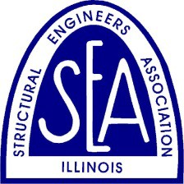

THE STRUCTURAL ENGINEERS ASSOCIATION OF ILLINOIS
Call for Special Awards Nominations 2020 John F. Parmer
SEAOI Service Outstanding Young Engineer
SEAOI Excellence in Engagement

The Structural Engineers Association of Illinois is pleased to announce its Call for Special Awards Nominations for 2020: John F. Parmer, SEAOI Service; Outstanding Young Engineer and SEAOI Excellence in Engagement. These awards recognize people in our industry who have contributed to the profession in a meaningful way, and it is an honor to highlight the recipients of these awards.

The John F. Parmer Award is presented to a structural engineer in recognition of outstanding lifelong contributions in the field of structural engineering. This award is presented jointly by SEAOI and the Structural Engineers Foundation. The candidate must be an individual whose distinguished career is acknowledged by his or her peers to be an example of excellence.

The SEAOI Service Award is given by SEAOI to a distinguished individual whose involvement and career services in design, construction, education, or business related to structural engineering has made a significant contribution to the advancement and the recognition of the role of structural engineers. The candidate must be active in his or her field or retired for not more than two years.

The Outstanding Young Engineer Award will be awarded to a practicing structural engineer aged 35 or younger (as of the date of the awards banquet) who is recognized by colleagues for his/her outstanding achievements in structural engineering.

The SEAOI Excellence in Engagement Award was established in 2019 to recognize individuals striving to improve engagement of current and/or future structural engineers. SEAOI is committed to improving engagement among our members and within the structural engineering community, and we wish to formally recognize others also committed to this pursuit.
This award, if presented, will be awarded to an individual or team in recognition of efforts to advance the profession by engaging current and/or future structural engineers within our industry.
To be considered for the award:
- Individuals must be practicing structural engineer or have retired within the last two years.
- Teams are defined as any joint endeavor or group operating collaboratively on a program or initiative within the structural engineering community and are not limited to formal organizational units. A significant portion of the team should be practicing structural engineers.

SEAOI members are invited to nominate individuals for any of the special award categories by accessing nomination forms here.

All Nominations must be received by Monday April 13, 2020.

NOMINATIONS REVIEW
Nominations for all awards will be reviewed by the SEAOI Awards Committee, and recipients will be selected by this committee. In the event of a tie, the SEAOI Board of Directors will make the final determination of recipient(s).

NOTIFICATION OF AWARDS
Recipients of awards will be notified in April 2020.

PRESENTATION OF AWARDS
Awards will be presented to recipients at the SEAOI Annual Banquet on Saturday, June 27, 2020 at the Old Post Office in Chicago, IL. All award recipients are invited as guests of SEAOI and are expected to be in attendance.

2019 SEAOI SPECIAL AWARD RECIPIENTS

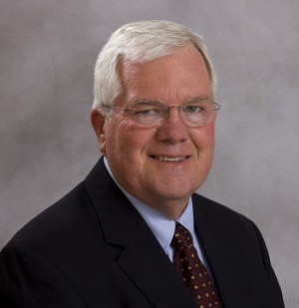
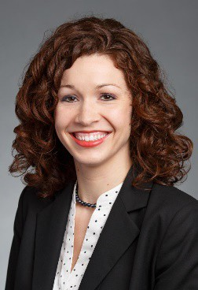
Donald F. Meinheit Michelle Ryland
Wiss, Janney, Elstner Associates Inc. Klein & Hoffman
JOHN F. PARMER AWARD OUTSTANDING YOUNG ENGINEER AWARD

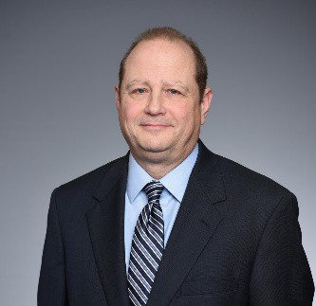
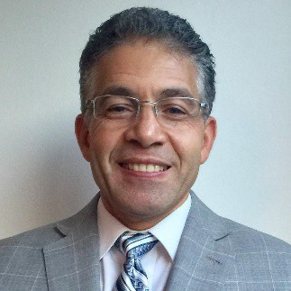
David Fanella Jamal Grainawi
CRSI WSP
SEAOI SERVICE AWARD EXCELLENCE IN
ENGAGEMENT AWARD

