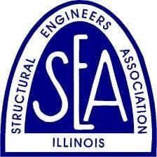
THE STRUCTURAL ENGINEERS ASSOCIATION OF ILLINOIS
Call for Entries
Excellence in Structural Engineering
Awards Program for 2022

The Structural Engineers Association of Illinois announces its Call for Entries in the Excellence in Structural Engineering Awards Program for 2022, the 43rd annual awards event conducted by the association.

PURPOSE
To recognize creative achievement in structural engineering via innovative structural designs and individual contributions that advance the profession.

ELIGIBILITY
Projects completed since January 1, 2019, are eligible. Projects must be completed or under construction as of January 1, 2022. Incomplete projects must be sufficiently complete to clearly show the basic design of the structural system. For this awards program, “design” may refer to the overall structure or an element that performs a key function within the completed structure. Any type or size of project may be entered, including new projects, renovations, preservation, rehabilitation, and adaptive reuse projects. The project need not be located in Illinois, but at least one member of the design team, or a principal of the firm responsible for the entry, shall be a member of SEAOI. Submitting an application for membership with an entry will satisfy this requirement. For entries in the Best Neighboring State category, at least one member of the design team, or a principal of the firm responsible for the entry, shall be a member of a neighboring state Structural Engineers Association.

CATEGORIES OF AWARDS
Awards will be presented for the following:
- Juror’s Favorite/Most Innovative Structure
- Best Bridge/Transportation Project
- Best Industrial /Utility Project
- Best Renovation/Retrofit/Preservation Project
- Best Special Structure
- Best Project – over $150 million
- Best Project – $50 million up to $150 million
- Best Project – $10 million up to $50 million
- Best Project – up to $10 million
- Lavicka Award – Small Firm/Small Project
- Best Neighboring State Project – designer located in a state neighboring Illinois

Project categories apply to total construction costs. The bridge/transportation category applies to any size of bridge; however, entries can be also submitted in individual cost categories. The winner of the Jurors’ Favorite/Most Innovative will be selected from entries in all categories.

One project will be selected to receive the Juror’s Favorite/Most Innovative Structure award. A project selected in this category, however, will not simultaneously be selected in one of the Best Project categories. Similarly, projects awarded the Best Bridge/Transportation and Best Renovation/Retrofit/Preservation Projects will not simultaneously be selected in one of the categories classified by construction cost. Finalists will be selected to make presentations at the SEAOI dinner meeting in May. One finalist will be selected to win each category of award. Finalists not selected as Juror’s Favorite/Most Innovative Structure or Best Project will receive Awards of Merit.

SEAOI and the Judging Panel reserve the right to withhold an award in a particular category should no entry be deemed worthy.

Lavicka Award
Thanks to the generosity of SEAOI past-President Bill Lavicka and his wife Alys, SEAOI is proud to offer the Lavicka Award, which is named in their honor and is reflective of the spirit of Bill Lavicka’s life and career. This award recognizes the high quality of work produced by small engineering/design firms as well as exceptional small projects and is open to small firms with less than 10 full-time employees, and/or projects up to $2 million. The entry fee for projects in this category is waived. With this award category, SEAOI looks to promote smaller firms/projects representing outstanding structural design.

AWARDS JUDGING
The initial review and selection of the finalists will be conducted by a subcommittee of the SEAOI Board of Directors. Firms are encouraged to submit as many entries as they wish. Bridge/Transportation and Renovation/Retrofit/Preservation Projects can be entered in those categories or the appropriate cost category. We reserve the right to move entries to another category.

A panel of distinguished judges will review the finalists’ entries and select the recipients of the awards. Selection of project awards will be based upon the material submitted with each entry, plus oral presentation by the finalists on Tuesday, May 3, 2022.

JUDGING CRITERIA
Projects
- Structural engineering achievement
- Creativity of structural design to meet the needs of the owner and architect
- Technical innovations and their influence on design
- How the design solves unusual problems
- Ingenuity of design for efficient utilization of materials and labor
- How the design or construction methods save time or money
- Suitability of the structure to its environment and sustainability
- Quality of execution
- How rehabilitated or renovated components are integrated into a completed structure
Most Innovative Structure /Jurors’ Favorite
- Technical advancement of structural engineering
- Unique application of structural design or materials
- Unusually creative solution to design challenges
- Creative design characteristics that merit special recognition

SUBMISSION OF ENTRIES
All entries must be made by an SEAOI member, or a neighboring state SEA member for entries in the Best Neighboring State category.

Entries must include the following:
- Completed entry form
- Concise description of project, outlining its significant attributes as they relate to the judging criteria (500-word maximum)
- Up to five photos, plans or sketches
- Entry Fee (waived for Lavicka Award; $400 for all other categories)

Entries may be submitted electronically on the Submission Page. Please include the appropriate photo credit in the file name.

DEADLINE FOR ENTRIES
All entries must be received by Friday, March 25, 2022.

FINALISTS
All project finalists will be required to provide unconditional release of photos for publication purposes. Credits should be properly noted.

NOTIFICATION OF AWARDS
Notification to finalists will be made after selection by the SEAOI Board of Directors in April. Announcement of Award winners will be made at the SEAOI Annual Banquet, to be held in June 2022. Details about the 2022 event will be forthcoming.

OWNERSHIP AND PUBLICATION OF ENTRIES
All entries become the sole property of SEAOI. No materials will be returned. SEAOI reserves the right to use or publish all entries and accompanying materials in SEAOI or other publications or for any and all editorial purposes. By entering, entrants grant a royalty-free license to SEAOI to use any copyrighted materials. Such right includes publication of photographs and names of award winners without compensation to entrants.

2021 Award Winners

Lavicka Award
BMX Bowls Bridge
Houston, TX
EndreStudio

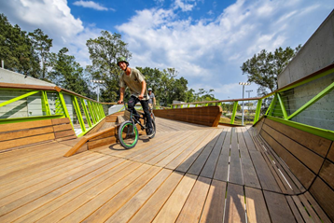

Best Project - up to $10 Million
1040 W. Fulton
Chicago, IL
IMEG Corp.

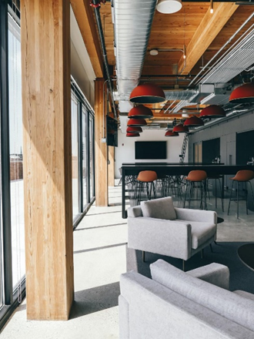

Best Project - $10 Million to $50 Million
RaviniaMusicBox Experience Center
Highland Park, IL
Wight & Company

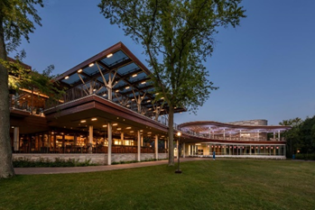

Best Project - $50 Million to $150 Million
Shenzhen Rural Commercial Bank Headquarters
Shenzhen, Guangdong, China
Skidmore, Owings & Merrill

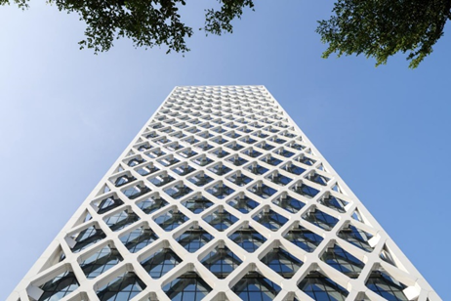

Best Project - over $150 Million
Circa
Los Angeles, CA
CKC Structural Engineers

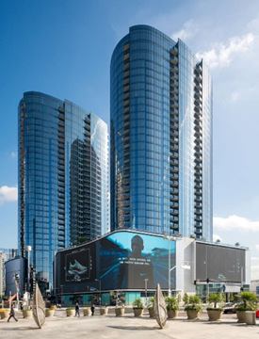

Best Renovation/Retrofit Project
Chicago Union Station - Clinton Street Improvements
Chicago, IL
Klein & Hoffman

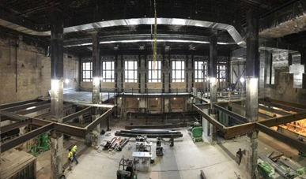

Best Bridge/Transportation Project
Lakefront Trail Pedestrian Bridge
Chicago, IL
HNTB

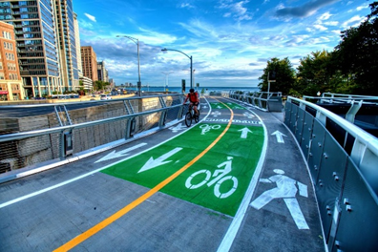

Best Industrial/Utility Project
Sooner Plant Units 1 & 2 Conveyor 10 & 11
Red Rock
Wolf Point Engineers

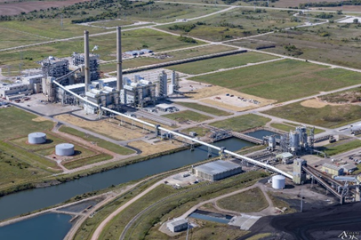

Best Special Structure
Robotic Construction - The Glass Vault
Westminster University, London, UK
Skidmore, Owings & Merrill

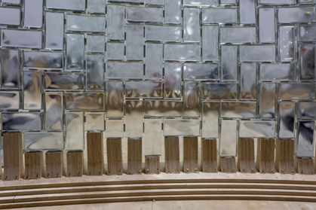

Jurors' Favorite/Most Innovative Structure
St. Regis Chicago
Chicago, IL
Magnusson Klemencic Associates
Photo: Angie McMonigal

